10.9 Practice
A Paradigms: Memorize future active, middle and passive paradigms of λυσω
Β. Parsing: Parse the following verbs:
 |  | 1/2/3 P | S or Pl | FAI  FMI  FPI | Meaning
1 | 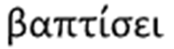 |  |  |  | He/she/it will baptize -βαπτίζω
2 | 
3 | 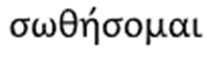
4 | 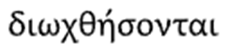
5 | 
6 | 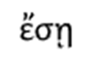
7 | 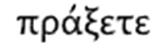
8 | 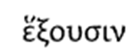
9 | 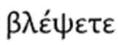
10 | 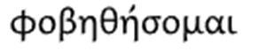

C. Translation (Greek to English)
1
2 | 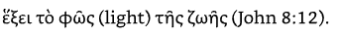
3
4
5
6
7
8
9
10
11 | πίστευσον (Believe!, imperative) ἐπὶ τὸν κύριον Ἰησοῦν καὶ σωθήσῃ σὺ καὶ ὁ οἶκός σου
12 | καὶ αὐτοὶ λαοὶ αὐτοῦ ἔσονται, καὶ αὐτὸς ὁ θεὸς μετ᾽ αὐτῶν ἔσται (Rev 21:3).
13 | ῥύσεταί (will deliver/rescue, middle-only verb) με ὁ κύριος ἀπὸ παντὸς (every) ἔργου πονηροῦ (evil) καὶ σώσει εἰς τὴν βασιλείαν αὐτοῦ (2 Tim 4:18).
14 | καὶ γνώσεσθε τὴν ἀλήθειαν, καὶ ἡ ἀλήθεια ἐλευθερώσει (will liberate) ὑμᾶς (John 8:32).

D. Translation (English to Greek)
1. | The apostle will glorify the Lord of truth.
 | The apostle (3 P S Nom) will glorify (FAI) the Lord (Acc) of (Gen) truth.
2 | We will not persecute the children.
3 | God will save the men who follow him.
 | God (3 P S Nom) will save (FPI) the men (Acc Pl) who follow (FPI) him (prep).
4  internet down | They will keep and practice the commands of God.
5 | You (pl) shall baptize the head of the house.

